Apple/iOS Device Wireless Set-Up

Apple/iOS Device Wireless Set-Up Tip Sheet 2017

To connect your Apple/iOS device to the Regional One Health wireless network, please follow instructions listed below.

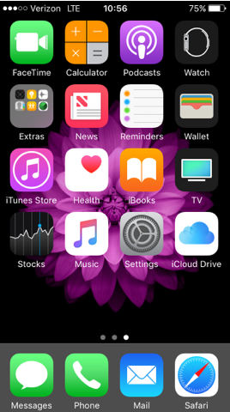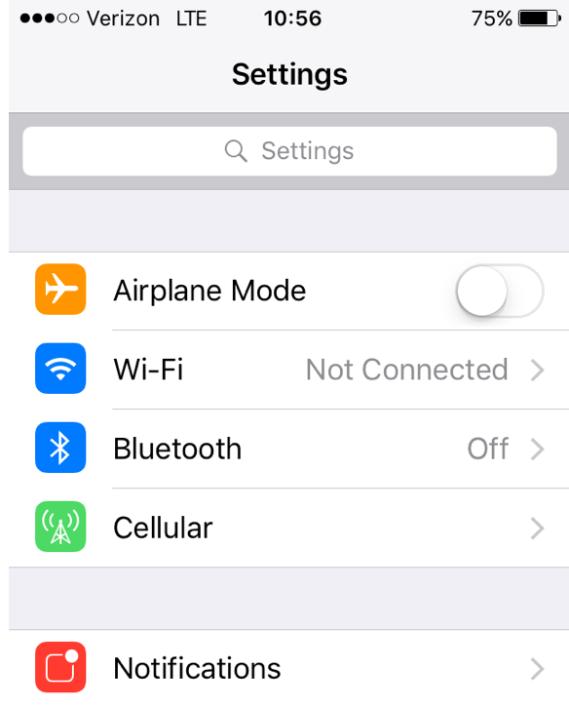
1. From your Apple device click Settings, then select Wi-Fi.

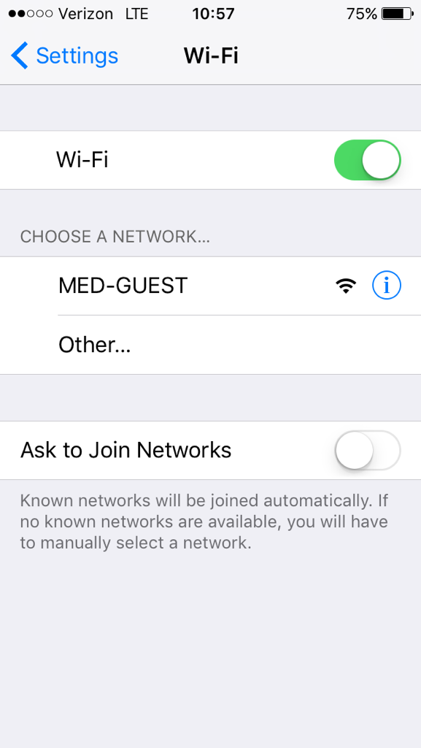
2. After selecting Wi-Fi, click Other.
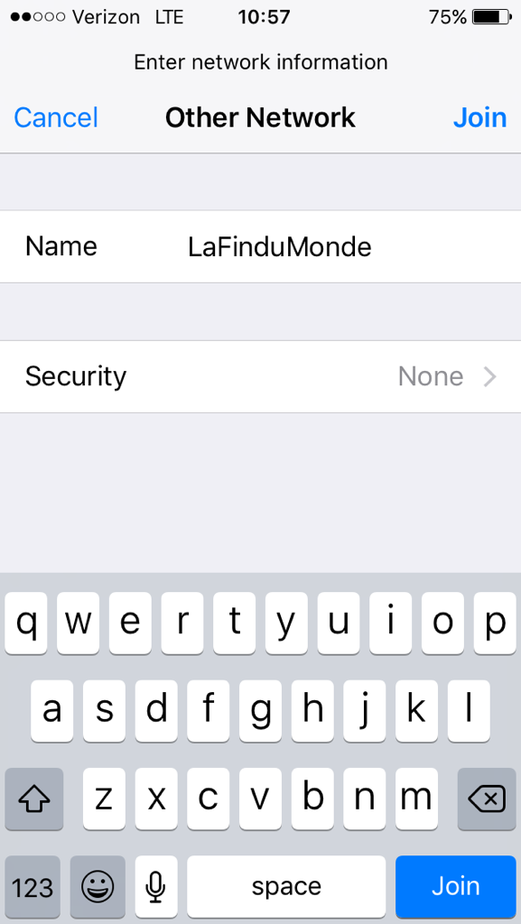
3. Enter the name LaFinduMonde (this is case sensitive) and select Security

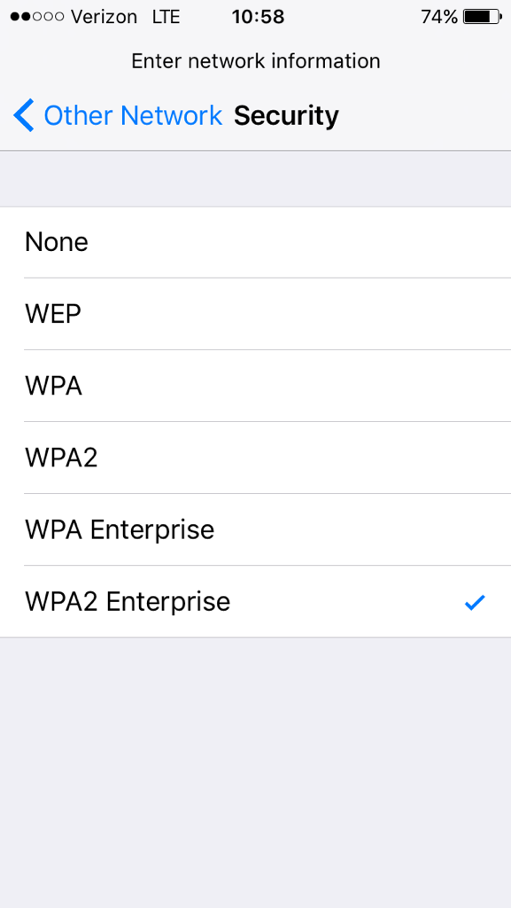
4. Select WPA2 Enterprise and press Other Network to return to the previous screen.

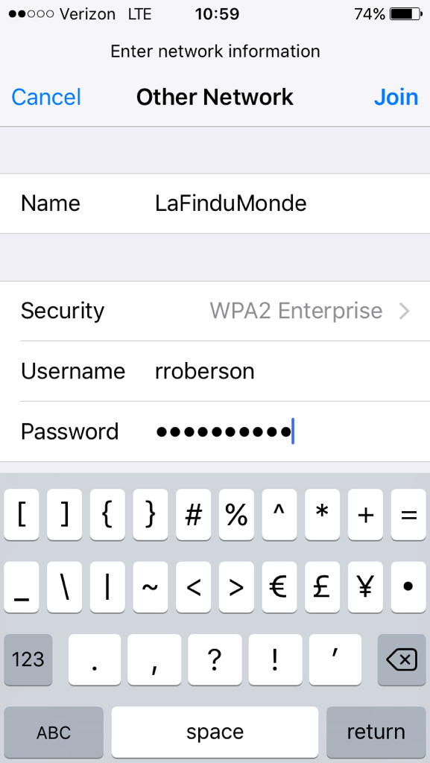
5. Enter your AD (Active Directory) login or Username and Password. This should be the login generated upon completion of your access request in Access Request Manager, then press Join.

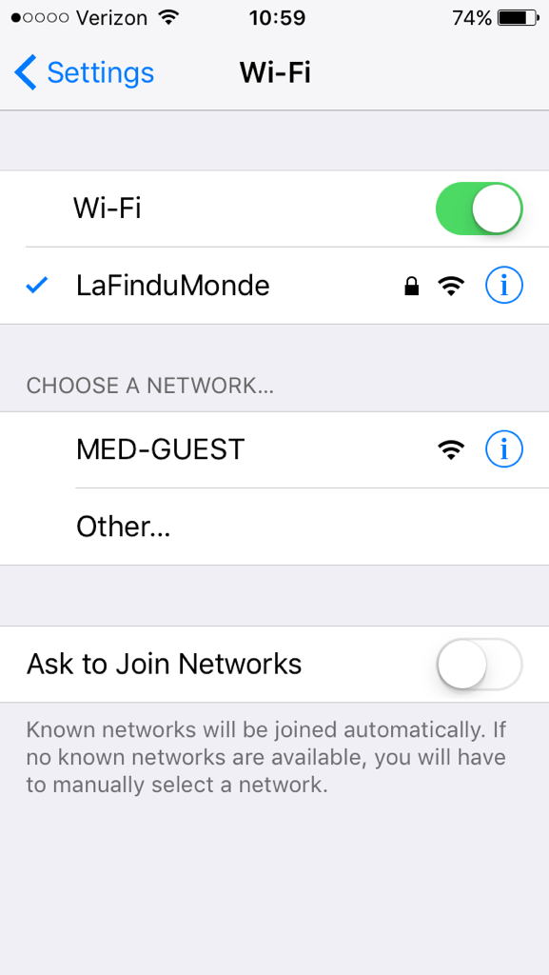
6. Note the in front of LaFinduMonde….you are now connected to the ROH wireless network. Press Settings to return to your home screen.

If you continue to experience connectivity issues, please call the Helpdesk at (901) 545-7480.

