Android Device Wireless Set-Up

Android Wireless Set-Up Tip Sheet 2017

To connect your Android device to the Regional One Health wireless network, please follow the instructions listed below.

Press the gearto open Settings, and click on Connections.

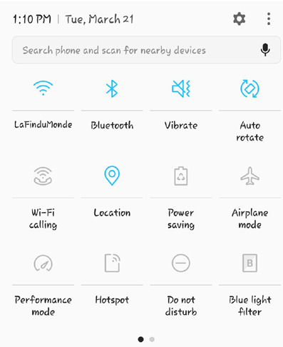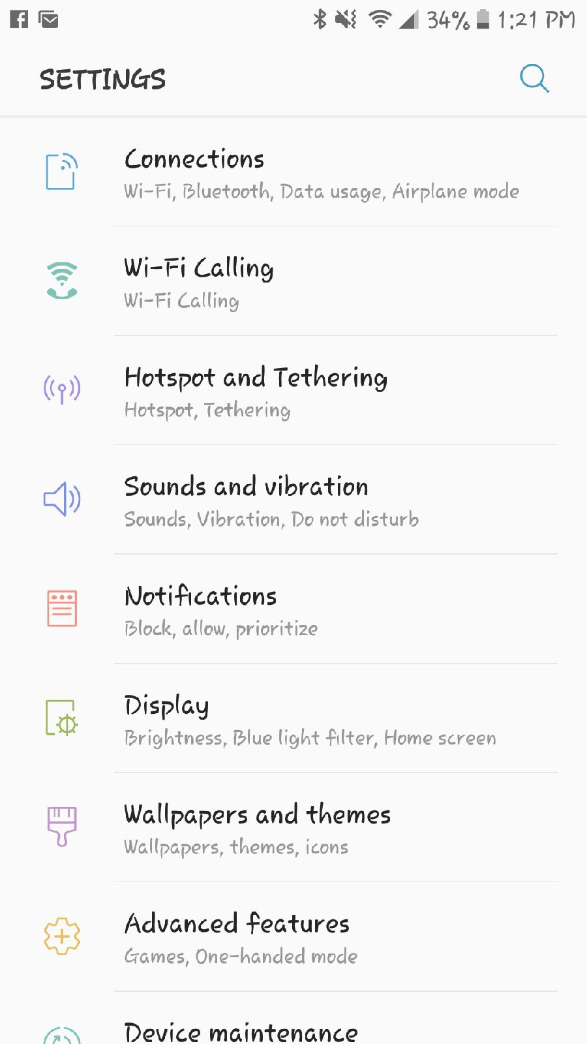

Next select Wi-Fi, then slide the ball into the On position and select Add network.

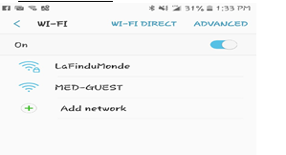

Enter network name LaFinduMonde (name is case sensitive) and from the security drop down box select 802.1xEAP.

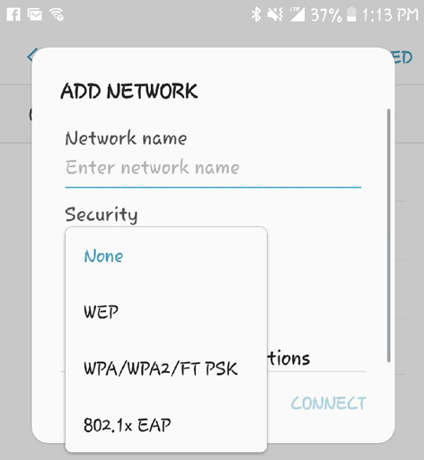

Now from the drop down boxes select PEAP for the EAP method and MSCHAPv2 for the Phase 2 authentication.

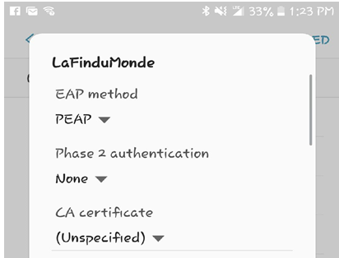
Select MSHAPv2 here

In the field labeled “Identity” enter your AD (Active Directory) login or Username and Password. This should be the login generated upon completion of your access request in Access Request Manager, and press Connect.

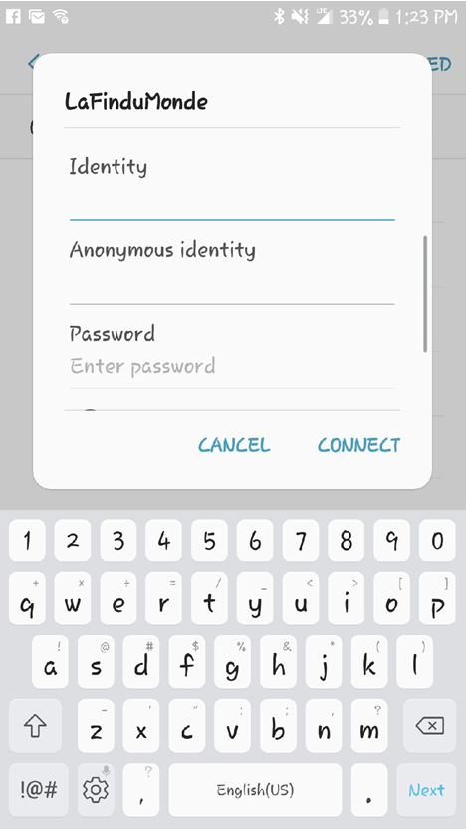
Enter your AD (Active Directory) login or Username and Password here.
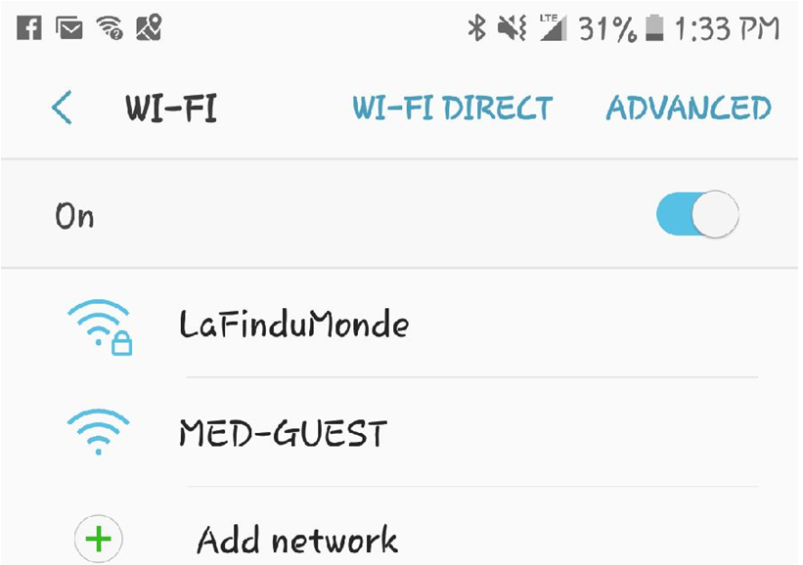
Note the 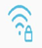 in front of LaFinduMonde….you are now connected to the ROH wireless network. Press to return to your home screen.

If you continue to experience connectivity issues, please call the Helpdesk at (901) 545-7480.

